**Task 3**

**Project: Event Management System using Postgresql**

Objective: To develop the application that allows users to create and manage events, track attendees and handle registrations efficiently. The project will include the following tasks

1. **Database Creation:**

Create a database named “EventsManagement.”

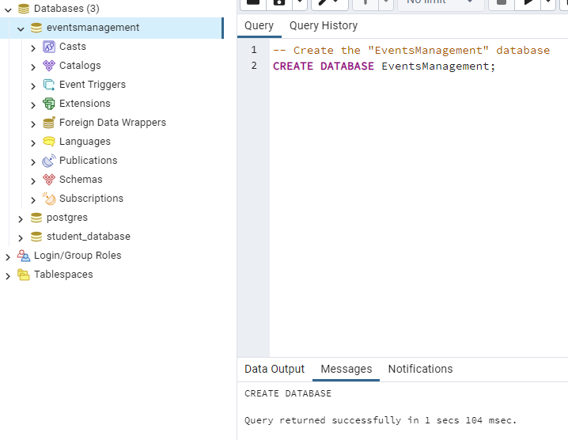

Create tables for Events, Attendees, and Registrations.

Events – Event_Id, Event_Name, Event_Date, Event_location, Event_Description

Attendees- Attendee_Id, Attendee_Name, Attendee_Phone, Attendee_Email, Attendee_City

Registrations- Registrations_id, Event_Id, Attendee_Id, Registration_Date, Registration_amount.

The FOREIGN KEY constraint in the Registrations table references the Event_Id column in the Events table and the Attendee_Id column in the Attendees table.

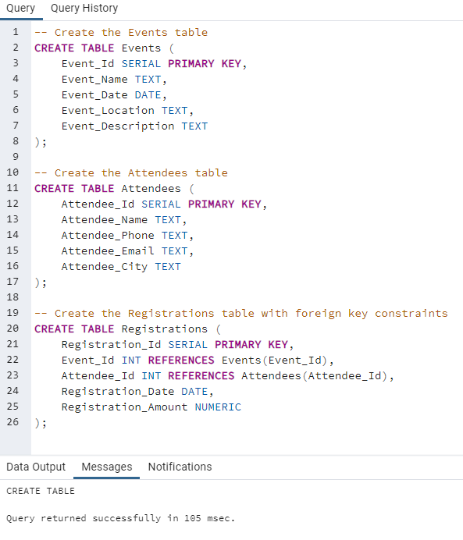

1. **Data Creation:**

Insert some sample data for Events, Attendees, and Registrations tables with respective fields.

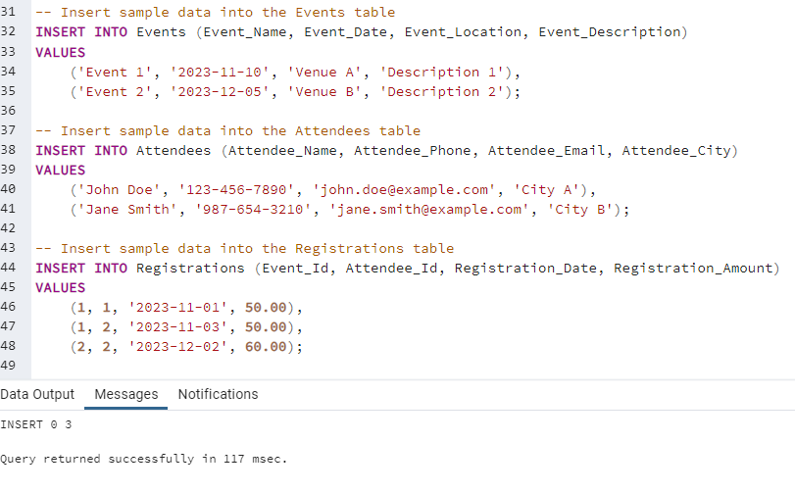

1. **Manage Event Details:**
2. Inserting a new event

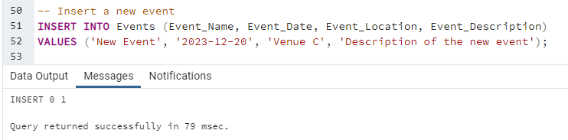

1. Updating an event’s information

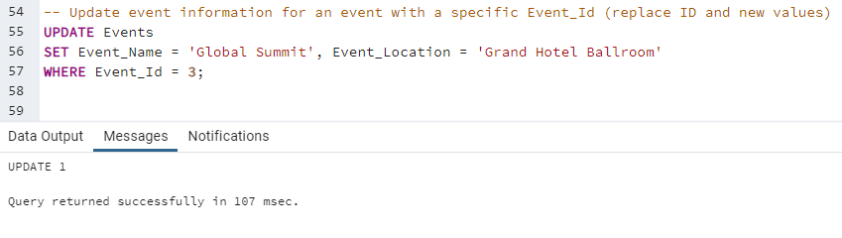

1. Deleting an event

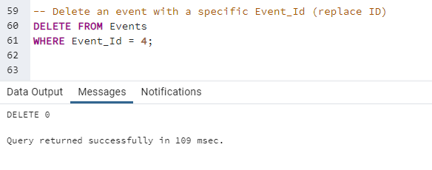

1. **Manage Track Attendees and Handle Events**
2. Inserting a new attendee

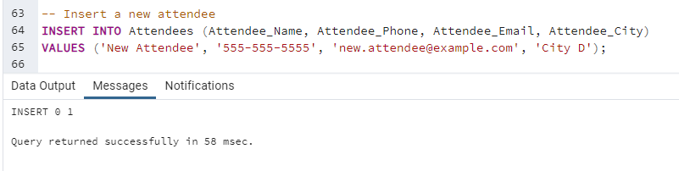

1. Registering an attendee for an event

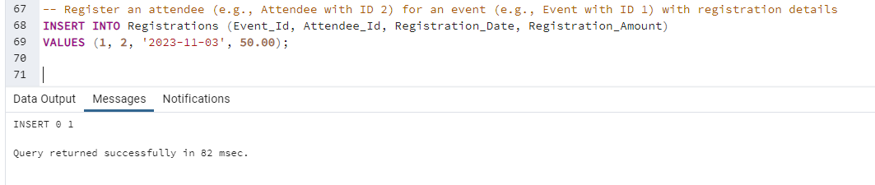

1. **Develop queries to retrieve information, generate attendee lists, and calculate event attendance statistics.**

For this step, we can create various SELECT queries based on the information we want to retrieve, attendee lists, and event attendance statistics. These queries will depend on our specific requirements and reporting needs. We can use standard SQL SELECT statements to retrieve the relevant data from your tables.

**Here are some example SQL queries:**

1. Retrieve Event Details by Event_Id:

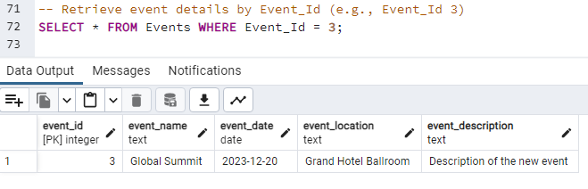

1. Retrieve a List of All Events:

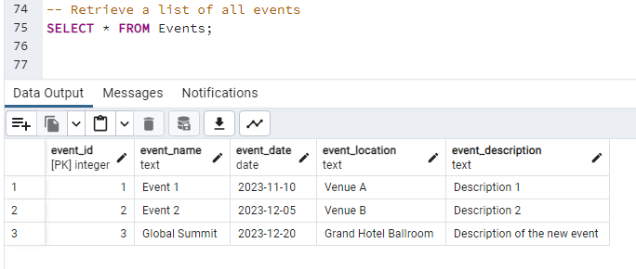

1. Retrieve Events within a Specific Date Range:

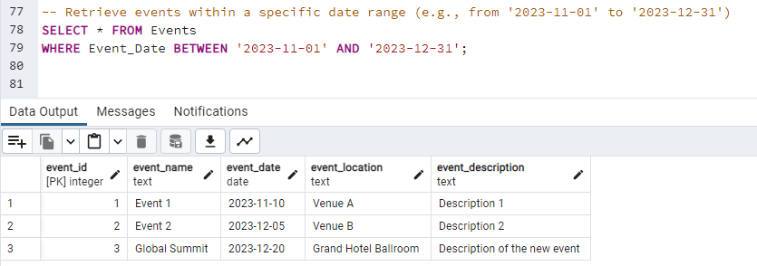

1. Retrieve a List of All Attendees from 'City A' Who Registered for Any Event:

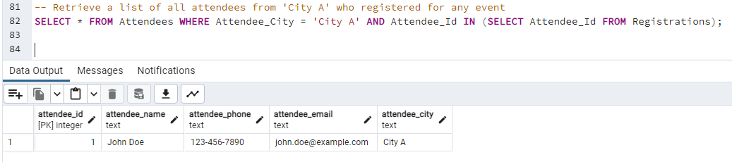

1. Retrieve Attendees for a Different Event by Its Name ('Event 1'):

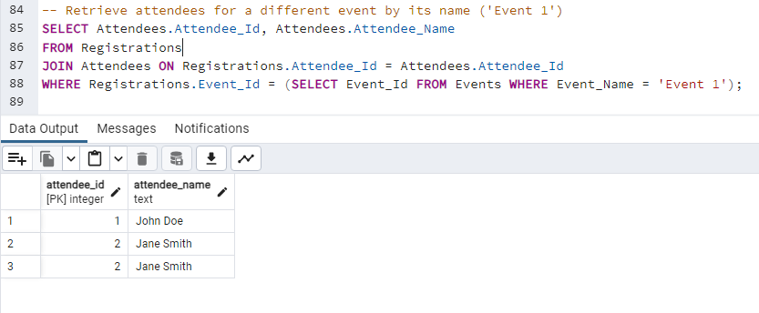

1. Calculate the Total Registration Amount for Events That Had More Than 2 Attendees:

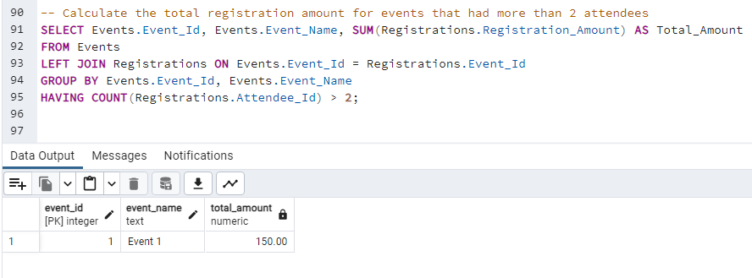

1. Calculate the Average Registration Amount for Events in a Different Location ('Venue A'):

